Team Number 10
Project Title: Intelligent and Collaborative Autonomous Robots for Real-Time Applications
Report Date: 9/23/2024
Part one: Progress status as a team
All team members have detailed tasks listed on Teams Planner: YES
Please answer the following questions:
- Have you met as a team this past week? If yes, give date/time, and the members attended the meeting. If no, explain.
  - Yes, team met in person on 9/23 all members attending at 4:30

- Have you met with the sponsor as a team? If yes, give date/time, and the member attended the meeting. If no, explain.
  - Yes we have met with the team sponsor on 9/23 at 7:10 pm in the lab

- Describe verbally the tasks completed the past week and the challenges faced.
  - This week we were able to access the camera's live feed for the unitree straight from the nanos. This involves accurately determining the process that runs the camera feed for the front. And from there we killed this process and Installing the updated Camera SDK repository we were able to. Run commands to open the video within the nano
  - At the moment, we still have not been able to reliably access Wi-Fi, However, we were able to use Internet when inputting a few commands to the terminal on the Raspberry Pi onboard the dog.
    - A side effect is that the dog can now broadcast Wi-Fi from its network.
- Describe the tasks to be completed the coming week.
  - For the following week we hope to have an idea of where to find the camera feed to incorporate our YOLO model
  - We are also going to be downloading our code to the dog,
  - A more long term goal is to create a Python script to run all of our terminal commands and seamlessly accessed the cameraSDK

Copy the following table from the last week’s report (09/16)
 | # Tasks completed past week | # Tasks not completed | # Tasks for next week
David Uzan | 0 | 2 | 4
Ian Simmons | 2 | 0 | 2
John Sinfuego

Fill in the following table for this week: (09/23)
 | # Tasks completed past week | # Tasks not completed | # Tasks for next week
David Uzan | 1 | 2 | 2
Ian Simmons | 2 | 0 | 2
John Sinfuego

Part 2: Individual Progress Report (each member complete one form)
Name of the Member: Ian Simmons
Report Date: 9/23/2024
List the following:
- All tasks completed the week before the past week (completion date in parenthesis). This is copied from the last report, and if this report is the first one, skip.
- All tasks completed the past week (completion date in parenthesis)
- All tasks you are currently working on or planned for this coming week (completion date in parenthesis)
For each task you have completed before the past week:
- Week 4, Task 1 (9/16)
  - Explore files within robot for usability in network access
    - It has been noted that there is a way to give access to the robot and it is possible that it is located within one of the directories within storage.
    - If found this may be a great start to setting up networking capability

- Week 4, Task 2 (9/16)
  - Find/Register Mac address to local network
    - This is another method that is an option for giving network access to the robot
    - The significance of having network capability is for us to be able to download repositories directly to the robot as the program is running. This will greatly speed up the time needed for computing operations

For each task you have completed during the past week:
- Week 5, Task 1 (9/23)
  - This next week my focus was on completing the process of accessing the cameras through the CameraSDK.
  - 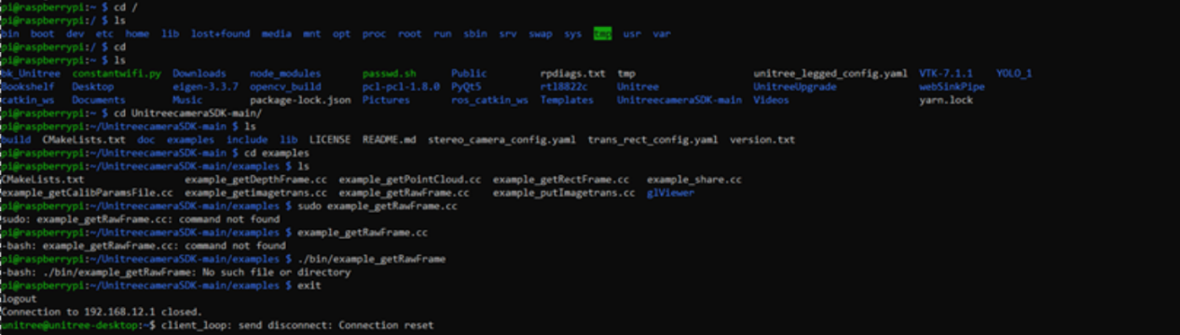
  - One of the main issues was the fact that the cameraSDK that was included was outdated and would not work the way we needed. Once the Ethernet was established we were able to download the updated repository and run our image transfer
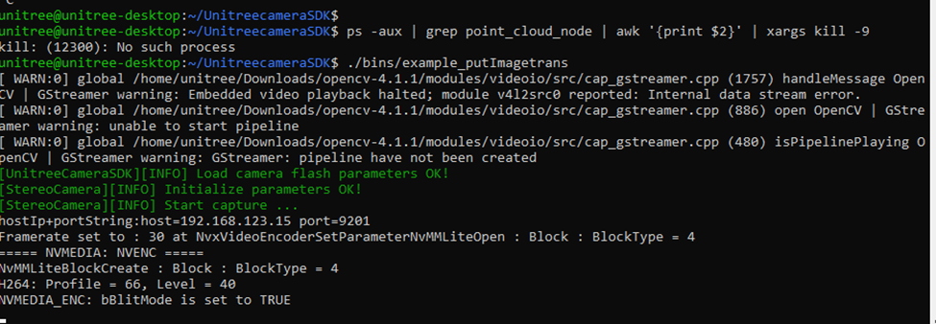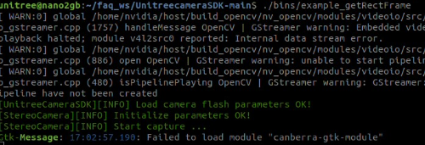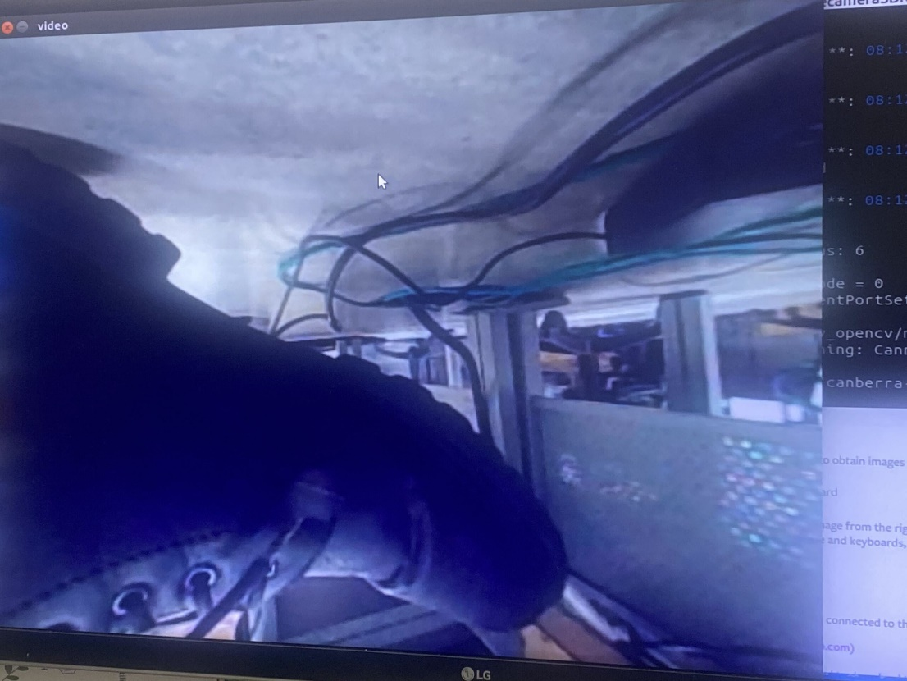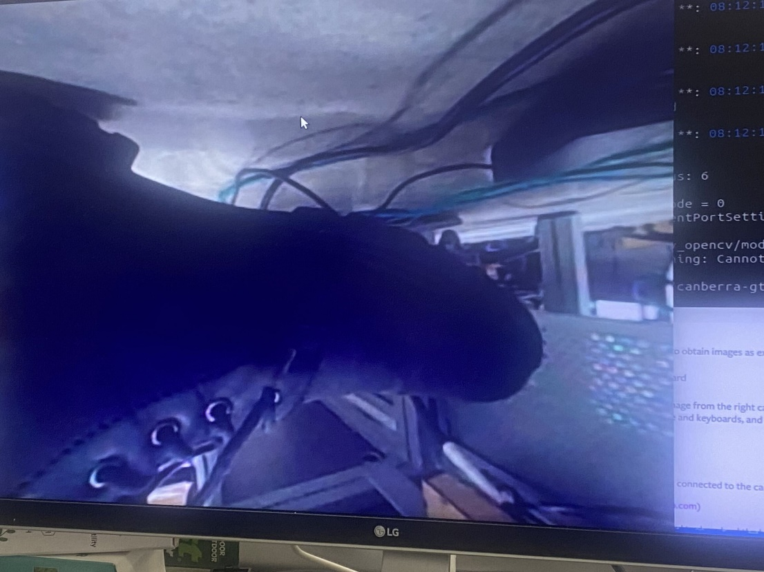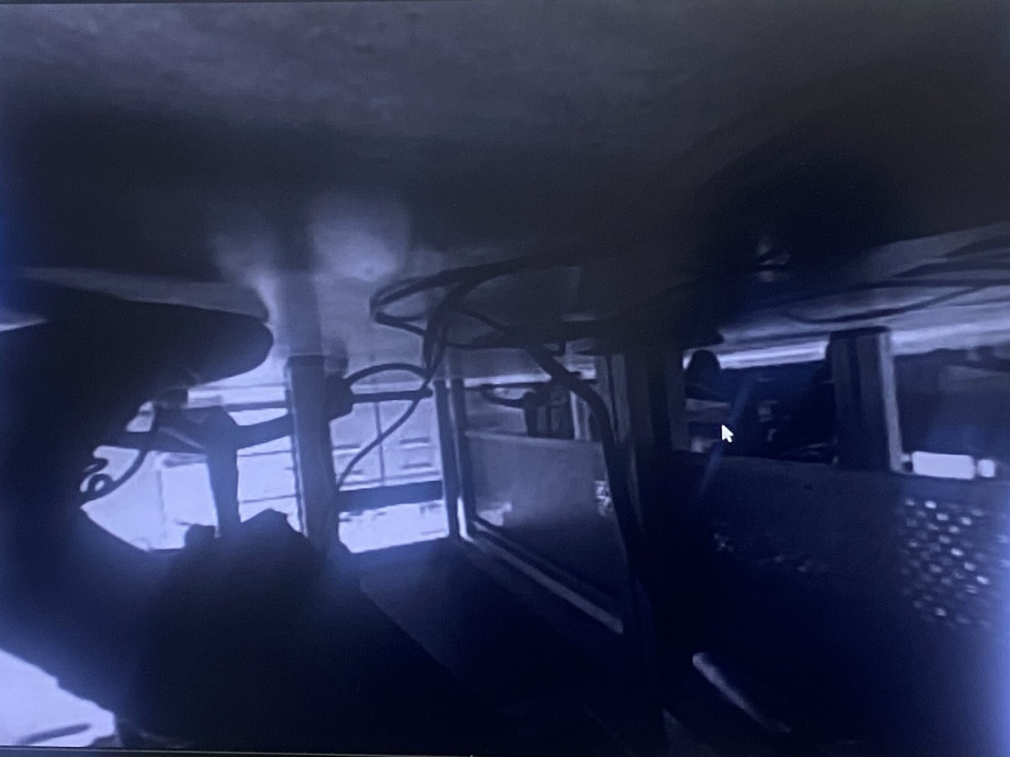

- Week 5, Task 2 (9/23)
  - Currently I am downloading the files and directories needed to stream the camera process to the local computer 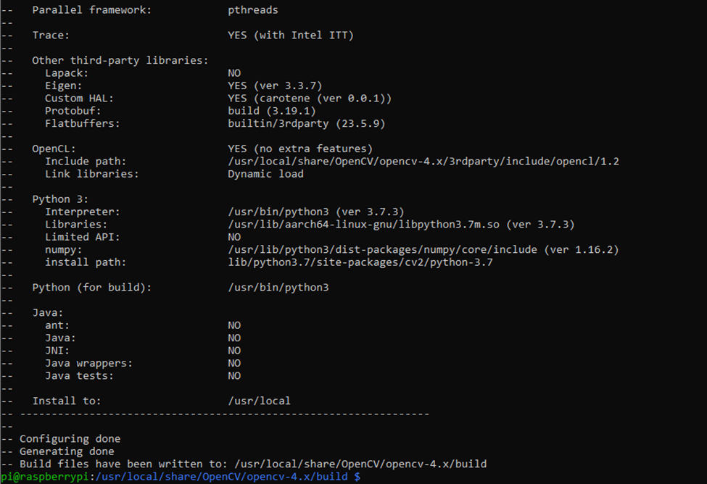
  - The issue is that these directories are all incorporated and are likely to run into small errors during execution]. while we were able to run the image transfer from one nano to the other at the moment the onboard pie is not updated enough and the build took a significant amount of time

For each task you are currently working on or plan to work on in the next period:
- Week 6, Task 1 (9/30)
  - I'll be installing Ubuntu on my local computer in order to circumvent the compatibility issues with windows and Linux
  - hopefully this will allow me to properly communicate with the dog without having to be directly connected via monitor and I can use SSH
  - If I can I will find a way to rotate the video feed but if not this may go into week 7

- Week 6, Task 2 (9/30)
  - I need to determine where the camera process is being initiated now that we have accessed it and are using it ourselves this will allow us to incorporate this source into our tracking model for object detection over live feed

Part 2: Individual Progress Report (each member complete one form)
Name of the Member: David Uzan
Report Date: 9/23/24
List the following:
- All tasks completed the week before the past week (completion date in parenthesis). This is copied from the last report, and if this report is the first one, skip.
- All tasks completed the past week (completion date in parenthesis)
- All tasks you are currently working on or planned for this coming week (completion date in parenthesis)
Preface for report: There is a difference in last week’s task count and this week because of redundance in task requirements.
For each task you have completed during the before the past week:
- Task number/name
N/A

For each task you have completed during the past week:
- Task number/name
Personal Week 4 (9-23-24) – Locate camera source directory in Uni-Go1

- Short description – these descriptions form the basis of the final project report
  - Implementation, testing, results
We located the file location that information is written down to by the robot by observing code used by students in the previous semester during their work with the system. The fashion they accessed the camera in killed the task and makes it unavailable for observation until the entire Uni-Go1 is reset, so we must look for alternative means of grabbing camera data.

  - Brief and to point
Camera locations were located using previous course work. We must be mindful to not kill the camera task when accessing it, as it is not possible to regain control once lost until a total system reset.

- Outcome of the task activity
  - How did the task advance your project?
We now have knowledge of which nano the cameras belong to and where their developer information is stored after access.

  - Include screen shots, link to videos, plots, data tables, designs, figures, etc. as evidence of your work on the task
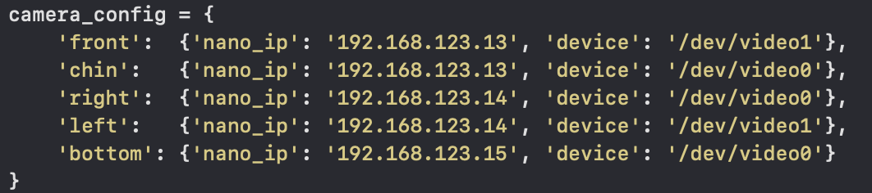
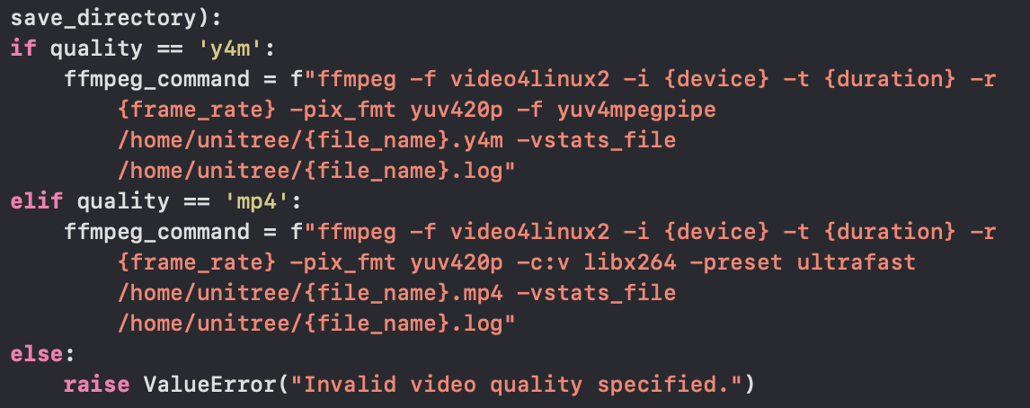

For each task you are currently working on or plan to work on in the next period:
- Task number/name
Personal Week 5 (9-30-24) - Add object detection python file to Uni-Go1
Personal Week 6 (9-30-24) - Run and display live tracking from robot

- Short description
  - Plans, resources needed, implementation, results
We will add a basic python source file to detect objects on live video feed from the robot when we gain control of its cameras.

  - Main challenges, reasons for any delay in completion
Camera access is still uncertain, and we must find alternative ways to reliably access the cameras if our current approach is inadequate.

- Outcome of the task activity
  - Include screen shots, link to videos, plots, data tables, designs, figures, etc. as evidence of your work on the task
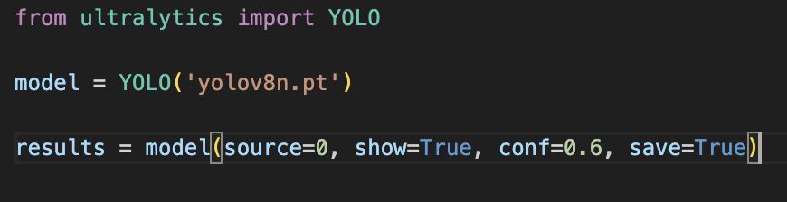
Simple code to detect and only display objects that the model can tell with 60% confidence or greater.

